**Heroes of Pymoli Analysis**

**Top Key Indicator:** The over whelming number of players of “Heroes of Pymoli” are male players. Male players encompass 84% of the total volume of players.

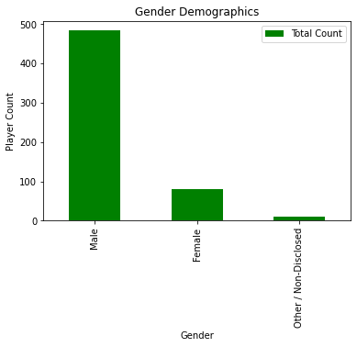

**Age Demographics:** Of all players, 45% fall into the 20–24-year-old age range. The next biggest group in age, is the 15-19-year-old group at 19% of total.

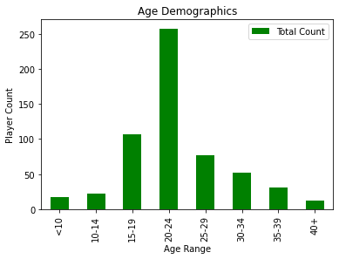

**Purchasing Demographics:** Although the 35–39-year-old group only encompasses only 5% of players, they average a higher total purchase price than all other user groups.

